Supply list for students:
Guaches  Some different colours… 1 black tube minimum  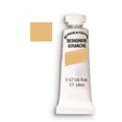  Pen:  Nr. 2,5 and 3 - Brause or TAPE  Nr. 1,5 – Brause or TAPE  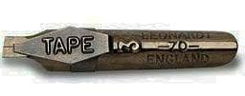  A mixing brush – not good ones  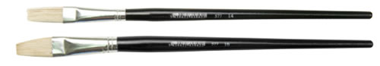  A mixing pallete  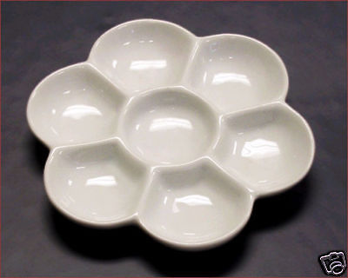 | Smaller Pad of paper for practicing with smaller sizes. (A3 or A4)  It is better Smooth – from 100 gsm  Participants can print the layout paper before the workshop on this paper, so that they can have lines already drawn on the paper.  One or two papers for final piece (A4)  For exemple:  Mi-Tients any colour (only few papers)  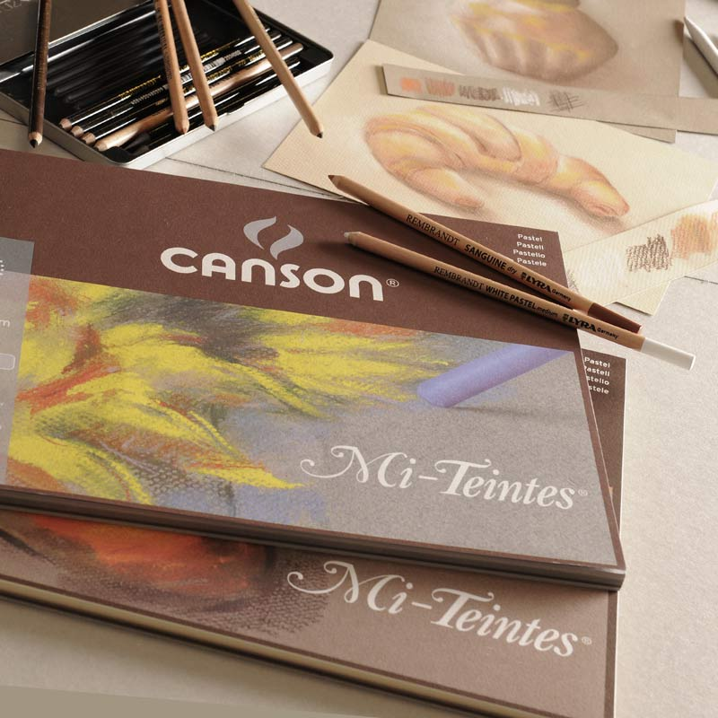  Few very soft - oily colored pencil:  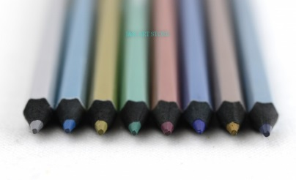  Other material:  Some texts, pencils, water container,  paper towels, ruler

